**Section 1:**

I am very passionate about cars and I love to research them. Given my passion for cars, I have designed a program which I have named Car bot. Car bot is a program which will accept user inputs and return a list of cars which they should consider purchasing. I have found a data-base which contains about 500 different configurations of 3 cars: a Ford f-150, a BMW 3 series, and a Toyota Prius. The user has to input a number based on a menu which I have provided of features which the user is looking for when shopping for a car. The list has six different options: luxury, fuel economy, body-type, drivetrain, transmission, and money. When the user selects a feature they are then prompted by either a list of cars from the data base or asked further questions if the user selects body-type, transmission, or drivetrain. After the user enters everything they are prompted for they are given a list of cars with the proper configurations which they should consider shopping for. In summary, the end result is a giant list of cars which match the user’s inputs. A screenshot of the user interface will be provided at the end of this report.

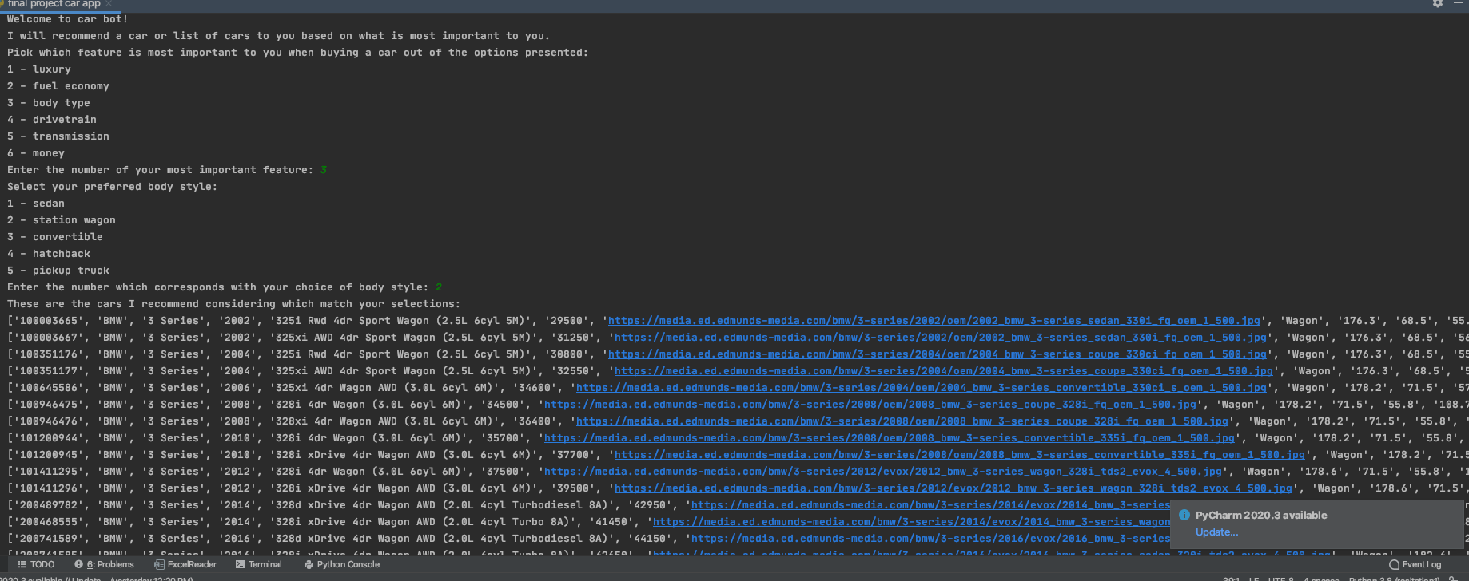

**Section 2:**

The target audience for my program is anyone who is currently shopping for a car or just interested in researching cars. I believe that this program if developed further can also be potentially used by car dealerships to maximize salesmen productivity and car manufacturers. This is because my program will recommend cars based on what the user wants. Normally, if one was shopping for a car it would take hours of research and countless trips to many dealerships to decide on a car however, with my program, it can be done in just a few minutes. In addition dealers could have this in their showrooms so customers can figure out which car they would like to test drive before even speaking to a salesperson thus making this process much more efficient.

**Section 3:**

I implemented many different programming techniques within my program. The most prominent technique that I used was decision structures. I have many functions which run off options that the user selects. For example my main function has the potential to run 6 different smaller functions based on if the user inputs a certain number. I will attach a screenshot of my code with all of my if-elif-else statements. In addition, I have also used files. My program outputs lines from a file/data-base which it reads and then prints out the lines based on the user input. The file is a csv file and my program reads it. I have also imported the csv library in order for my program to be able to read the file and I have used a for loop for my program to be able to read each line in the file and filter out what the user wants. I also simplified my program by defining separate functions within my main one and then calling them in main. My data was collected by me opening the csv file globally so that all my functions can use it and I don’t have to open it each time within each function. It is analyzed by a for loop and by using other decision structures. 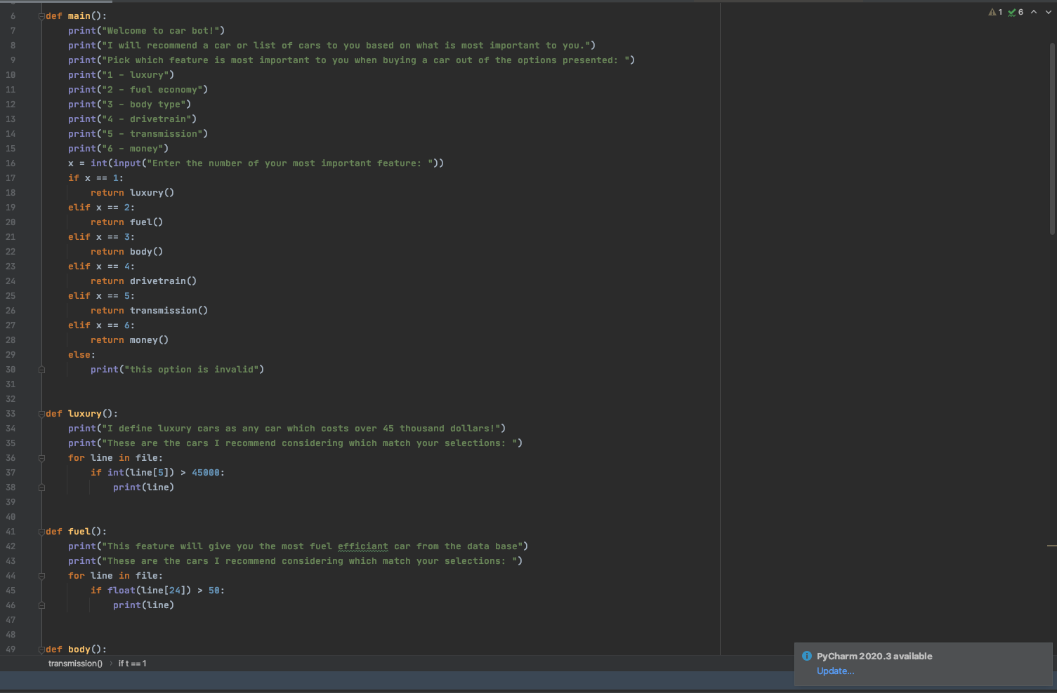

**Section 4:**

My biggest challenge with my design was modifying the csv file so that all the columns and rows matched up and could be read by my program. The data which I have used was very unorganized and had many errors and inconsistencies within it. I had to manually fix all of the data myself. Another major challenge which I encountered was figuring out which features to offer the user to choose from. There are countless specifications a car can be in so therefore I had to figure out how to prioritize and only let the user decide from what they are interested in. Finding a database with all my information that I needed was also tricky. I overcame most of these problems by modifying the csv file manually and researching what features people are most interested in when shopping for a car.

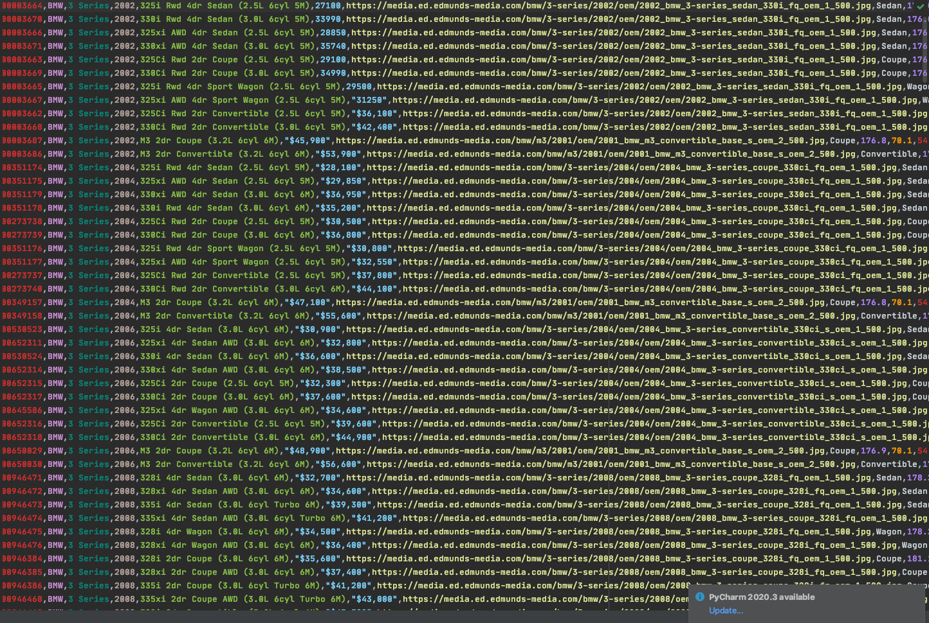

**Section 5:**

There are many extensions and improvements I would like to make in the future given I had more time. The biggest improvement I would like to make is filtering and reading the file using multiple user inputs at the same time. I would like the user to not have to just pick one thing most important to him. I would like the user to be able to select all of the options from my menu and filter by everything at once. For example if the user wants a fuel efficient pickup truck which is a manual transmission, I would like him to be able to search for that instead of just getting a list with all the pickup trucks. In addition I would also like to add more features to filter the database by. Finally I would also like to implement this program in an app which I would design in the future.